Lake Washington Improvement Association Board Meeting October 4, 2022
Board Members Present: Mike & Sandy Wosmek, Lyle Walker, Pat Hanson,
Ron Bubany, Steve Grotbo, Steve Ullom, David Rathe, Sharon Daniels, Laurie Johnson, Mark Johnson, Brett Rassmusen,

Treasurer Report: Invasive Species Fund $49,713.64 General Fund $72,716.68
Paid Memberships: 214
1) Call Meeting to Order 7 PM by President Steve Grotbo
2) Secretary's September Board Meeting Report- approved for publication on the website.
3) Treasurer's September Financial Report – Lyle W reported INCOME $315.00: $50 Dues, $116.67 interest from Perennial Bank CD (paid two times per year), $60 Ad payment for Newsletter, $88.33 from EZ Dock for meat and buns for Pot Luck. EXPENSES $2664.21: $825.30 Fall Newsletter, $393.63 Info. Systems annual renewal, $54.63 water quality testing mileage, $1339.00 West Bend Ins. (Board liability insurance), $31.65 Lake Steward sign for Ellsworth landing. $2240.00 were donated to the Dassel Fire Dept. by 77 people this year, Lyle will be sending a check to them sometime in October. Board approved this report.
4) Dam height – Steve G. reported Ethan Jenzen provided an article for our fall newsletter. Basically nothing can be adjusted without agreement of property owner on both Lake Washington and Stella. The Board has heard from owners with low lying properties opposed to raising the water level, so closing out any further discussion on this.
5) Culvert replacement- DNR approval has been received and bid scheduled to go out in October.

6) Lake Steward- Steve G reported Lake Steward signs are up at both Ellsworth Landing and his place. For Ellsworth Landing, Mike Wosmek and Steve G put up the sign last Friday.

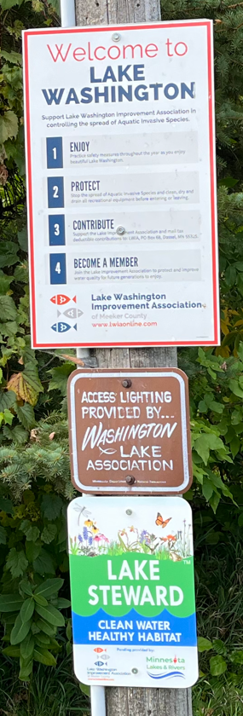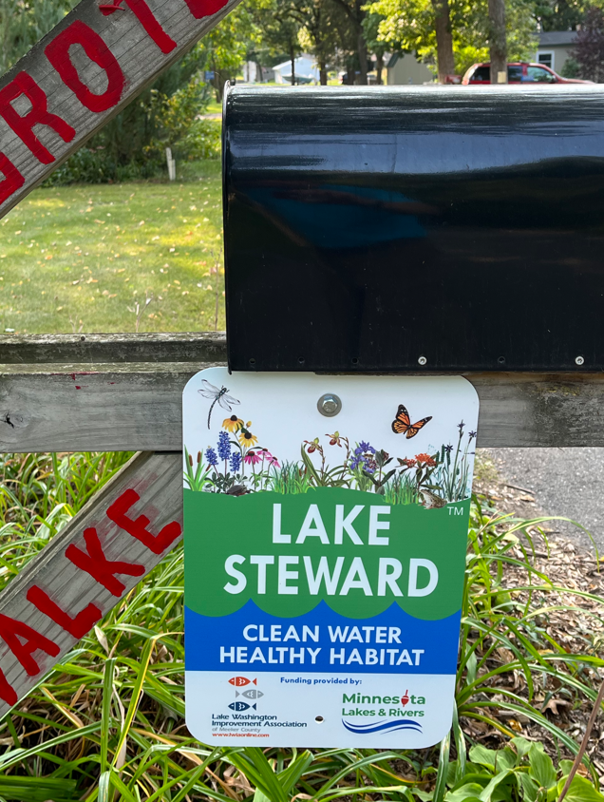

(Lake Steward continued) Mike W read through the Lake Steward booklet and noted they are suggesting that the Lake Association have landscapers to recommend to those interested in this program. After a discussion the Board determined, for liability reasons, LWIA will not be making recommendations for landscapers to do the lake shore improvement necessary for this program. Steve G’s interpretation of qualifying would be anyone that does or has done lakeshore improvements and requests Lake Steward status. He would grant them approval because he is the lake contact person for this program
7) Committee Report
Aquatic Invasive Species:
A. Water Quality Testing – Dave R reported the August testing results were Phosphorus 30.2 and
Chlorophyl 9.8. Historically for August the Ph has been 28.4 and Chlorophyl .8. He was sure the low water levels have an impact on these readings. Seechi readings were 5 feet on 9/19/22. The MPCA is requesting water temperature readings whenever a seechi disk reading happens. Dave will be sending all the data collected this year to the MPCA near the end of October.
Dave has designed new data charts for water quality testing information and updated them on our website.
B. Vegetation Survey – Mark J, Mike W. and Ron B report they found zero EWM and very little American milfoil on their latest survey. Steve G reported he was pleased with near shore vegetation treatments this summer.
C. I-LIDS/Watercraft Inspection – Dave R reported the DNR had decontamination station at the Ellsworth landing on Sunday Oct. 2. He will be taking out the I-LIDS soon. Ray B has begun viewing their video.
D. Cormorants & Pelicans – Steve G reported No large flocks of cormorants / pelicans on the lake lately. Spoke with Spring Lake person last week and they are seeing the same situation of no cormorants / pelicans. Not sure where they went, but assume they will be back in spring.
E. Zebra Mussels – Dave and Mike collected the hotels on Labor Day, noting there lots of immature mussels on the inspection plates. They noted more on north side of the lake than the south side. Dave contacted area AIS person about getting information to them. He also sent our information to MAISRC, but has not heard back for them. We will continue putting out the hotels as a means of gathering data on the year to year cycle of the zebra mussel populations in Lake Washington.
Steve G reported The “2022 MAISRC Research and Management Showcase” still only has last year’s videos at https://www.youtube.com/c/maisrc. Looks like no one from the Board signed up this year so, it seems like we won’t get access until later in the year unless someone paid the money.
F. Watershed – Mike W reported the survey crew is scheduled to come out once the leaves have fallen to scope out the culvert and ditch across the road from the Nelson farm.
Membership / Shoreline Captains – Laurie J reported this time last year we had 206 memberships, compared to 214 this year. Sandy W has been working on getting several new people to be Shore Line Captains and is continuing to update this list. Laurie has sent out updated Shore Line Captains lists and set May 20, 2023 for Shore Line Captains meeting next spring.
Education & Public Relations:
A. Fall Newsletters – It is done and looks really great and will be going out soon. Thanks Ron!!
B. Website, Facebook, and Email Activity – Ron B reported there are things being updated on the website. He will be letting a subscription to Word Process Package, that we don’t use expire at the end of the year.

Social Committee – Lyle has LWIA on Rod n Gun Club calendar for next year: May 6 Pork Chop Membership and
August 5 Pot Luck..

Financial – Grants -Sharon D – MCAL grant application has been submitted. She is doing year end reports then working on applying for 2023 grants, AIS due 10/20/22. Continue sending her in-kind hours, she will roll those not on this years tally to next year.
MCAL - Representatives/meeting dates Pat H reported next meeting Oct. 20 7pm Litchfield.
8) Open Discussion

Next Board Meeting Scheduled for February 7th via Microsoft Teams.

